Explanatory Statement
Australasian Catchment Water Improvement Standard (ACWIS) Method for accounting for fine sediment abatement through improved grazing land management.

V1.0
February 2026

Table of contents
Issue Statement 3
GLM Method Overview 3
• Dynamic Reference Cover Modelling 3
• Revised Universal Soil Loss Equation 3
Explanatory Statement: 5
Section 1 – Project Description 5
Section 2 – Project Eligibility 5
Section 3 – Project Mapping and Data Requirements 5
Section 4 – ACWIS Credit Project Plan (GLM Plan) 6
Section 5 – Project Accounting 6
Identifying Dynamic Reference Cover Pixels 7
Determine Seasonal Project Baseline 7
Determine monitoring period adjusted groundcover 7
Determine RUSLE factors ‘R’, ‘K’, ‘S’, and ‘C’ 8
Sediment abatement calculations 9
Relevant Pools 9
Accounting for leakage 9
Accounting for disturbance events 9
Section 6 – Monitoring and Record Keeping Requirements 9
Appendix 1: Project Accounting Steps 10

Issue Statement
Sediment flowing into Australia’s rivers, wetlands, estuaries and coastal waters degrades aquatic ecosystems, reducing water quality and limiting the resilience of freshwater and marine habitats. Many catchments across Australia are identified as being at risk from accelerated erosion associated with land use. This Methodology, referred to as the Method (or GLM Method), quantifies measurable improvements in sediment reduction resulting from improved grazing management and enables the generation of credits where there is demand for verified water quality outcomes.

GLM Method Overview
The GLM Method will generate ACWIS Credits that incentivise landholders to achieve fine sediment abatement. Grazing land management improvements under the GLM Method aim to achieve a higher level of groundcover before high intensity rainfall periods, reducing the likelihood of hillslope fine sediment run-off and maximising the benefits to local waterways and catchments.
The Method minimises the effects of external influences such as seasonality by applying Dynamic Reference Cover Modelling (DRCM). This ensures crediting only occurs for changes in grazing land management activities. Calculations under the GLM Method are based on a refined sediment delivery model known as the Revised Universal Soil Loss Equation (RUSLE).

Dynamic Reference Cover Modelling
Dynamic Reference Cover Modelling (DRCM) is used to adjust ground cover changes for seasonal influences. Under this Method, minimally disturbed areas (pixels) termed ‘reference areas’ are used to benchmark changes in groundcover through time. These areas can be thought of as ‘control’ areas that are compared against areas where grazing land management changes have been implemented. The Method assumes changes in reference area ground cover is a result of weather and climate influences rather than grazing land management or other disturbances. Calculating the difference in ground cover between the reference and project areas is therefore a measure of grazing management impact on ground cover.

Revised Universal Soil Loss Equation
After the reference areas are identified through DRCM, the RUSLE (Figure 1) is applied to each project area pixel to calculate sediment runoff.
RUSLE factors required for the calculations under the GLM Method include:
- R – Rainfall, runoff erosivity
- K – Soil erodibility
- L – Slope length (topographic factor)
- S – Slope steepness (topographic factor)
- C – Cover management
- RF – Rock Factor
- P – Practice management
Note that Cover management is the only RUSLE factor that can be influenced through grazing land management within the GLM Method. Rainfall aside, the assumption is that all other factors remain constant at the pixel level. The precision of the Method therefore relies on unbiased ground cover measurements that is achievable via remote sensing.
Figure 1: RUSLE Factors and data
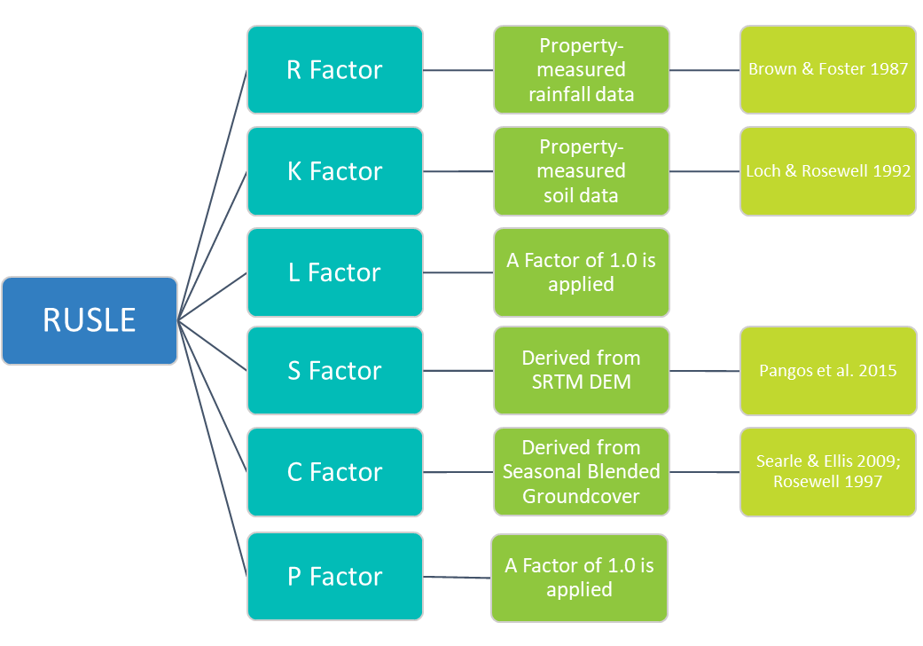

Explanatory Statement:
A statement for each section of the GLM Method is provided below.

Section 1 – Project Description
This section of the GLM Method details the summary information required to register a project. The GLM Method is structured to encourage whole of property, and/or enterprise-wide projects. This will incentivise landholders to think holistically and more easily manage the risk of leakage, i.e., moving cattle to non-project areas to maximise Credit returns on registered project areas.
The distinction between the Project Area and the Credit Accounting Zone(s) (CAZ) is very important. The CAZ is the explicit area where sediment abatement is calculated, while project activities occur across the whole Project Area.

Section 2 – Project Eligibility
Credits under the GLM Method can occur where grazing is the principal land use. A 25-year crediting period ensures long-term benefits for the grazing enterprise and the environment.
Section 2 details project exclusions, including:
- Irrigation – The RUSLE requires a rainfall factor that might be confounded through irrigation. There are calculations that will cater for this but excluded from the GLM Method for simplicity.
- Fertiliser application – Fertiliser has potential negative impacts to water quality if leeching occurs. Like irrigation, areas receiving fertiliser application are excluded.
- Broadscale clearing – Clearing has negative impacts on the environment and an excluded activity for accounting purposes. There are conditions for cleared areas to be include in the CAZ after 15 years from the date of clearing.
To participate, landholders will need to develop a Grazing Land Management (GLM) plan outlining their approach to improving grazing practice and reducing sediment run-off across the Project Area. Further, to qualify for Credits, a project must meet specific additionality requirements.
Section 2 also includes a detailed description of leakage risk management. Two scenarios are identified for consideration:
- Scenario 1: Land beyond the Project Area (including other properties) within the operational control of the project participant/s of the same agricultural enterprise.
- Scenario 2: Land within the Project Area but not within the CAZ, e.g., land not monitored by satellite ground cover mapping due to having > 60% woody vegetation.
Project proponents must complete the steps stated under section 2.6.1 of the GLM Method. This is required at the time of the project application and for each monitoring period to determine if there is a risk of leakage, and if so, implement the appropriate procedure to account for leakage.

Section 3 – Project Mapping and Data Requirements
Mapping is required to identify Project Areas and the CAZs. There is no need to exclude infrastructure from Project Areas. However, project proponents are encouraged to map infrastructure as inputs into the GLM Plans.
Project proponents should consider identifying discontinuous land as separate CAZs. This will help divide the Project Area by broad land units and ensure representative reference and project pixels are identified. The project calculations must be run separately for each CAZ.
Rainfall intensity measurement
Rainfall needs to be measured within the project area using a calibrated tipping bucket rain gauge. This gauge must report data in 6-minute increments (i.e., successive periods of time with each period being no longer than 6 minutes) and meet required accuracy standards, allowing it to capture the expected range of rainfall rates effectively.
Fine Sediment proportion
Project proponents must create a soil sampling plan that stratifies the CAZ for FS proportion sampling. The minimum number of strata should correspond to the unique values found in the mapped Soil Australian Soil Classification (ASC) raster that intersect with the CAZ. For each identified stratum, the minimum number of surface (0 - 15 cm) soil collection points will be either three samples per stratum or one sample for every 200 hectares of that stratum, whichever is greater. Particle size analysis to determine the FS proportion from bulked samples by strata must be conducted by a National Association of Testing Authorities (NATA) accredited laboratory.
K Factor
As part of the soil sampling plan and data collection, information is required to inform the K Factor. This includes estimating the soil profiles infiltration rate, and assessment of the surface soil structure.

Section 4 – ACWIS Credit Project Plan (GLM Plan)
GLM Plans should align with the aims of the grazing business enterprise. Plans need to cover the entire Project Area and include strategies that are expected to increase ground cover.
Plans must be kept for the duration of the crediting period and be reviewed, updated, and submitted at the end of each monitoring period with the application for ACWIS Credits.

Section 5 – Project Accounting
The GLM Method calculates the delta between sediment delivery from an adjusted baseline scenario and a project reporting period scenario. The adjustment masks seasonality influences (i.e., periods of prolonged wet/dry weather) and calculates the proportion of sediment saving achieved through grazing management improvement.
Sediment savings only occur when it rains, therefore Credits under the GLM Method are only issued for actual sediment abatement achieved. The level of ground cover directly influences sediment delivery, with higher ground cover reducing run off and soil loss. For this reason (and to capture rainfall events at appropriate intervals), RUSLE calculations occur seasonally for the baseline period and reporting period.
Project accounting is conducted in two parts:
- Baseline period cover analysis
- Reporting period sediment calculations.
Project Accounting steps are provided in Appendix 1.

Identifying Dynamic Reference Cover Pixels
The GLM Methods uses DRCM to identify areas least impacted from grazing management activities and sets these as ‘control’ areas.
Figure 2: Identifying reference pixels (for each season)
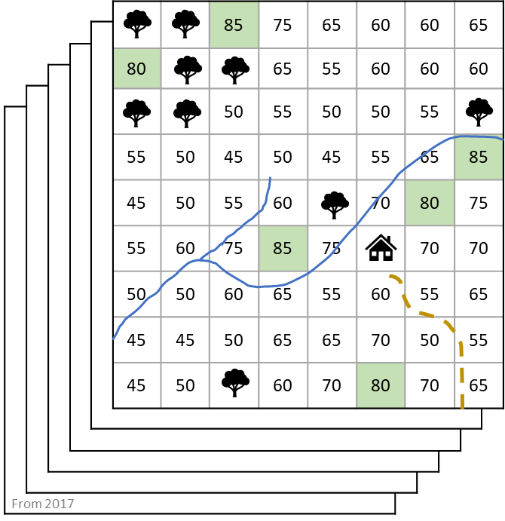 | Steps:  - Download relevant data, apply 10km buffer on the Project Area.  - Identify the lowest groundcover percentage for every pixel using all data within the baseline period  - Create a minimum cover layer from this data, then select all pixels within the highest 90-95 percentile range (the green pixels in this example).  - These are the reference pixels. All other pixels in the Project Area are referred to as project pixels.

Determine Seasonal Project Baseline
It is necessary to establish a baseline of past ground cover and behaviour. Having defined the reference pixels, calculate the difference in ground cover between the average of the reference pixels and each Project Area pixel for each season. This difference is the baseline for each pixel.

Determine monitoring period adjusted groundcover
During the project period, it is necessary to reset the DRCM pixels to include all capture dates between the project start and the end of the reporting period (repeat the process described in Figure 2). This limits any effects that changed practices or disturbances have on the average reference pixels by removing areas that may have recently come under pressure.
Using the updated reference and project pixels, determine the difference in ground cover from the reference pixels and each project pixel within the monitoring period. Then, compare these with the baseline expected difference and calculate the delta between the difference expected from the baseline and difference observed during the project period. Refer to Figure 3. The results are then used to adjust the actual captured season groundcover as a separate baseline input into the RUSLE calculations.

Figure 3: Project Accounting (Example)
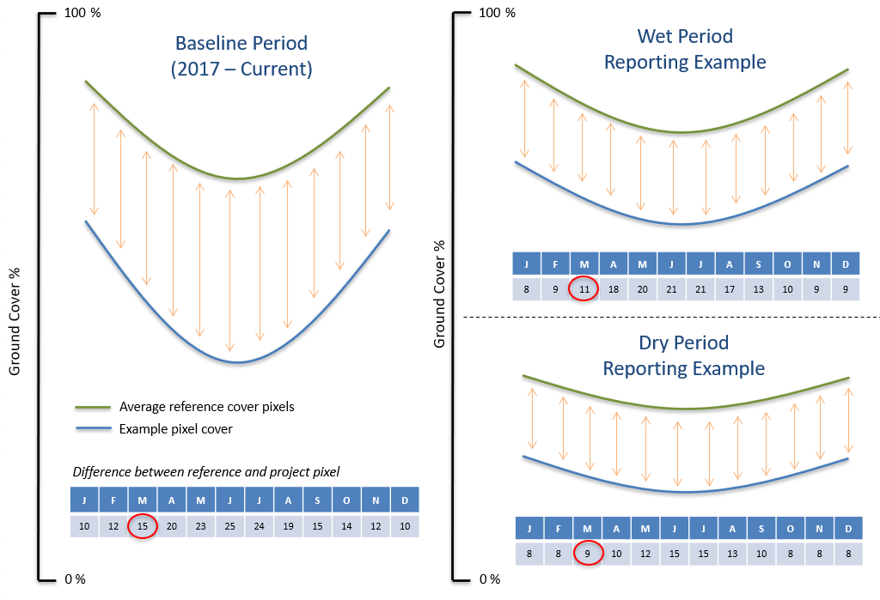
Notes on Figure 3 (March example):
- For the baseline period (left half of Figure 3), the difference between the average cover of reference pixels and an example project pixel is 15% (noting a difference is recorded for each project pixel, this is a single pixel example).
- During a wet reporting period (top right of Figure 3), the average ground cover increases for both the reference pixels and the example pixel. The difference between the two is now 11%, a 4% improvement from the baseline that was 15%.
- During a dry reporting period (bottom right of Figure 3), the average ground cover decreases for both the reference pixels and the example pixel. The difference between the two is now 9%, a 6% improvement from the baseline that was 15%.
Run RUSLE using the ground cover as measured and ground cover adjusted to the baseline. The difference can be credited to grazing management improvement.
Note: This is a monthly example, apply the same approach to seasonal data (three month average)

Determine RUSLE factors ‘R’, ‘K’, ‘S’, and ‘C’
The factors that require calculations before input into the RUSLE are rainfall erosivity (R), soil erodibility (K), and cover factor (C). The GLM Method utilises the following:
- R - factor from measured rainfall data
- K – factor from soil sampling
- S – factor from STRM DEM
- C - factor from ground cover

Sediment abatement calculations
With all the factors, including the C factor for the measured ground cover, and a C factor for the modelled ground cover, calculate two spatially explicit RUSLE layers (measured and modelled). The difference is the benefit and can be used for crediting.

Relevant Pools
While the Method will calculate total sediment loss and abatement, only fine silt and clay fractions are subject to sediment reduction Credits. Project proponents must identify and record the proportion of fine sediment in soils and multiple this by the total sediment at the farm gate. Further, sediment delivery ratios assumes a proportion of fine sediment will never reach assets at risk. Total fine sediment abatement needs to be multiplied by these ratios.

Accounting for leakage
The concept of project leakage arises because actions taken in one location might lead to changes in behaviour or land use elsewhere, indirectly influencing the net sediment benefit. For example, if a GLM project succeeds in sediment abatement in a particular paddock, it might encourage the landowner to move cattle to a nearby paddock and increase grazing pressure, thereby offsetting the gains achieved by the original project.
Project leakage is an important consideration when evaluating the overall effectiveness of ACWIS Credit initiatives. To ensure project integrity and credibility, project developers must carefully assess and account for potential leakage effects in their calculations and implementation plans. By doing so, they can take measures to mitigate unintended consequences and ensure GLM projects genuinely contribute to sediment reduction efforts.

Accounting for disturbance events
Any natural and unmanageable disturbance, for example, fire originating from a neighbouring property, will impact ground cover and crediting. Project proponents may delay reporting on disturbed areas until site recovery has occurred or exclude affected areas from reporting for 12 months after any event. Evidence of disturbance events must be provided.

Section 6 – Monitoring and Record Keeping Requirements
This section sets out monitoring and record-keeping requirements under this GLM Method. Reporting may occur annually, not exceeding 5 years.
A Monitoring Report must be submitted for each monitoring period. The project proponent must monitor the CAZs and Project Areas for potential leakage and compliance with the Grazing Land Management plan. The monitoring report must include documentary evidence that confirms the stated GLM activities occurred during the monitoring period. The monitoring report must also include detail of all disturbance events. These may be excluded from the CAZ for the monitoring period (up to 12 months).

Appendix 1: Project Accounting Steps
The following steps are provided to assist with meeting the conditions of the GLM Method.
Table 1: Project Accounting
Project Accounting Steps | Equation(s)
Collect data and undertake project mapping
Download data:  - Section 3 of the GLM Method | NA  (Geo Tiff)
Map Project boundaries:  - Project Area – Whole of property or grazing enterprise  - Credit Account Zone(s)  - Irrigation areas  - Disturbance history, i.e., fire and land clearing | NA  (Shape file)
Identify Baseline Dynamic Reference Cover Pixels
Determine baseline seasonal ground cover proportion (for baseline period):  - Derived from government supplied monthly blended ground cover as defined in Section 3.4 of the GLM Method. | 1
Identify reference and project pixels for the baseline period:  - Create a minimum ground cover layer for all seasons (equation 2).  - Select reference pixels from 10km Project Area buffer (equation 3).  - Assign all remaining pixels in the Project Area as project pixels (equation 4). | 2, 3, 4
Determine Seasonal Project Baseline
Using average reference and individual project pixels from the step above:  - Calculate the spatial difference in ground cover for each season over the baseline period (equation 5).  - Account for regulated minimum ground cover if required (equation 5).  - Calculate the average calendar seasonal difference in ground cover between reference and project pixels for the baseline period (equation 6). | 5, 6
Identify monitoring period and adjust ground cover
Identify reference and project pixels from baseline period to project reporting date:  - Create a minimum ground cover layer for all months (equation 2).  - Select reference pixels from 10km Project Area buffer (equation 3).  - Assign remaining areas within the RCAZ as project pixels (equation 4).  - Calculate the difference in ground cover between the reference and project pixels for the monitoring period (equation 7).  - (Equation 8) - Calculate the difference of the difference. That is ground cover difference during monitoring period (equation 7), minus ground cover difference during baseline period (equation 6).  - Adjust seasonal ground cover to respect the difference (equation 9). | 2, 3, 4, 6, 7, 8, 9
RUSLE Modules ‘R’, ‘K’, ‘S’, and ‘C’
R Factor - Rainfall erosivity:  - Using minimum 6-minute interval pluviograph data from the site monitoring station, calculate storm rainfall erosivity (equation 10).  - Calculate seasonal R value (equation 11). | 10, 11
C Factor - Cover:  - Calculate seasonal C value - measured (equation 12).  - Calculate seasonal C value - adjusted for the baseline expected difference modelled (equation 13). Respecting regulated minimum ground cover. | 12, 13
S Factor – Slope  - Calculate land surface slope (equation 14) | 14
K Factor – Soil erodibility:  - Interpolate non-dispersed particle size analysis (equation 15)  - Convert organic carbon to organic matter (equation 16)  - Calculate wet sediment density from non-dispersed particle size analysis (equation 17)  - Calculate K from results and equations above (equation 18) | 15, 16, 17, 18
Benefit Attenuation Factor (BAF) - Sediment abatement calculations
- Apply option 1 or 2.  - If option 2, for case B where there is phased separation without infrastructure, calculate BAF (equation 19)  - If option 2, for case C where there is phased separation with infrastructure, calculate BAF (equation 20) | 19, 20
Relevant Pools - Sediment abatement calculations
- Run RUSLE for each season of the monitoring period using both the measured C value and the baseline modelled C value.  - Account for fine sediment proportion and the delivery ratios (equation 21). | 21
Accounting for leakage
- Account for leakage when considered ‘likely’ (equation 22). | 22
ACWIS Credit Calculation
- Apply the correction factor to convert the fine sediment abatement to an equivalent ACWIS Credit (equation 23). | 23

